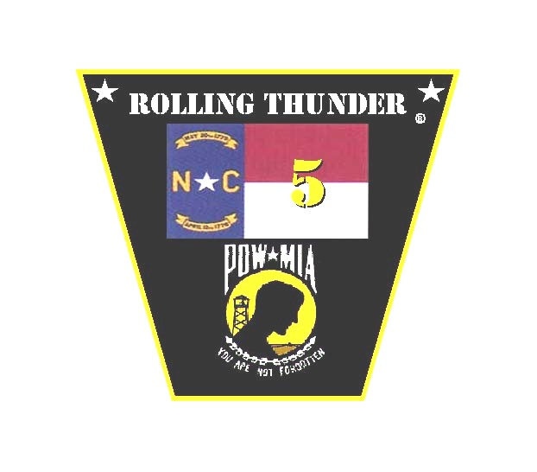ROLLING THUNDER®, Inc.
Chapter NC-5

PO Box 306
Jacksonville, N.C. 28541
(910) 389-7319

14 December 2015
Dear potential sponsor:

Rolling Thunder®, Inc. Chapter NC-5 is inviting you to help us help our veterans by becoming a sponsor in our 14th Annual “Chilly Chili Poker Run.” The 2016 run is scheduled for February 20.

Profits from your sponsorship will go towards the “SSgt Anthony L. Goodwin Memorial Veteran Dependents Scholarship Fund”. SSgt Goodwin was a member of 1st Bn, 2nd Marines, and was killed during combat operations in Iraq on Mother’s Day of 2005.

This scholarship fund has now been active for 10 years and has been set up to provide any dependent child of a military veteran who is enrolled in a college program a chance to earn an additional boost to help defray the cost of attending that college. Last year our Chapter awarded four scholarships.
How does this sponsorship work? By becoming a sponsor you will gain advertising on the back of our official Poker Run T-Shirt. As an added benefit, each sponsor will receive two free T-shirts as a thank you from our organization. There are a limited number of sponsorships available.
Sponsorship is only $100.00.

By sponsoring, you can be assured you have helped a high school student reach his/her dream of going to college. Thank you from the members of Rolling Thunder®, Inc. Chapter NC-5.

Paul Levesque
President

